**Unity API (Input System, Collision and Trigger Methods)**

**LAB # 5**



**Fall 2024**

**CSE-411L Intro to Game Development Lab**

Submitted by: **Ali Asghar**

Registration No.: **21PWCSE2059**

Class Section: **A**

“On my honor, as student of University of Engineering and Technology, I have neither given nor received unauthorized assistance on this academic work.”

Submitted to:

**Engr. Abdullah Hamid**

Date:

**21st December 2024**

**Department of Computer Systems Engineering**

**University of Engineering and Technology, Peshawar**

**Objective:**

In this lab we further explored the Unity API.

**Tasks:**

- Open/create a Unity scene.

- Create a player cube that moves forward, backward, left, and right.

- The camera in the scene should be set to a top-down view.

- The scene should have a plane with a maze on it (see the following picture for reference).

- The walls of the maze should be made from cubes of different sizes.

- At the start of the scene, there should be a sphere (ball) and a player cube. When the player moves the ball to the goal in the middle of the maze, the goal should turn green.

- If the ball touches the walls of the maze, the walls should turn red and return to normal when the ball moves away from them.

- Additionally, when the player touches the ball, the ball should turn yellow. When the player releases the ball, it should return to white.

**Code:**

**Player class**

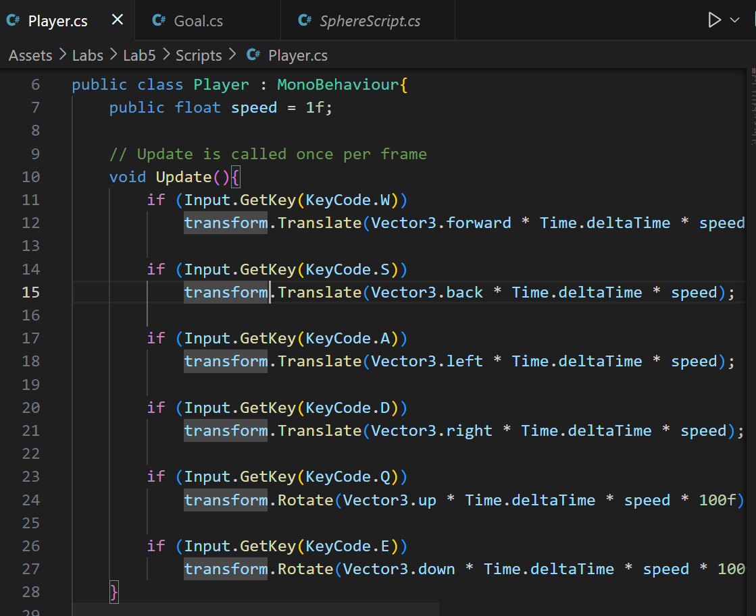

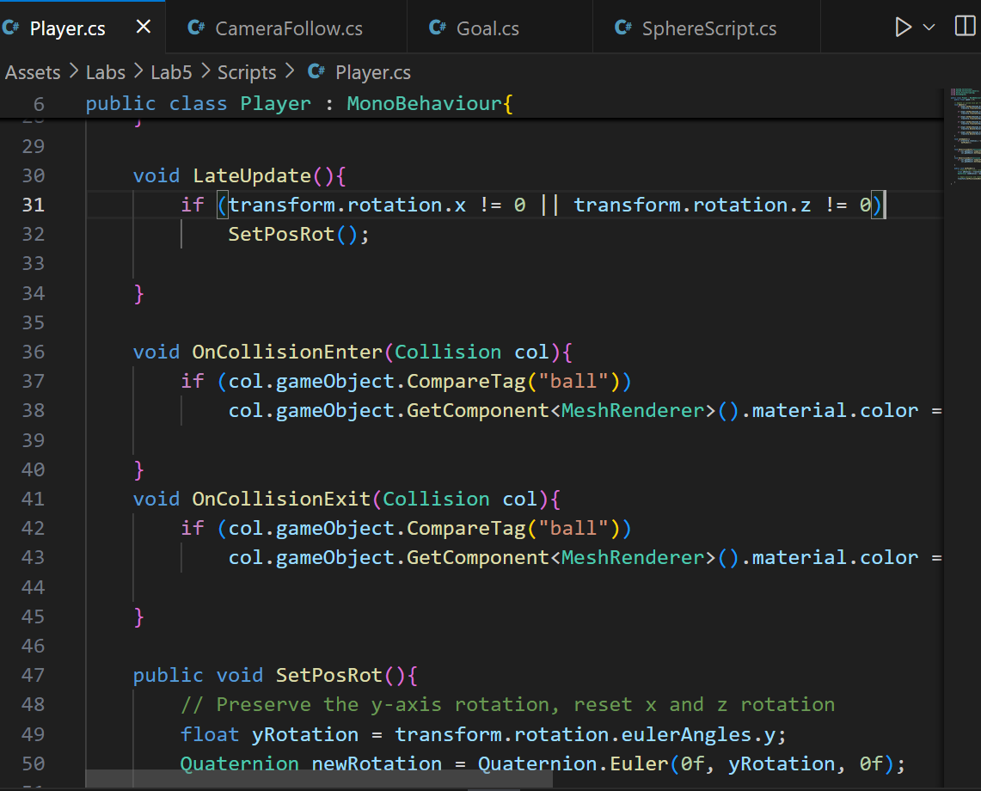

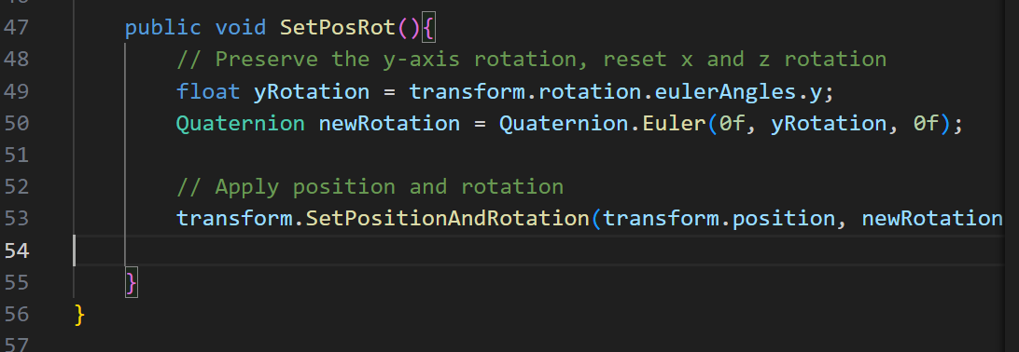

**Goal class**

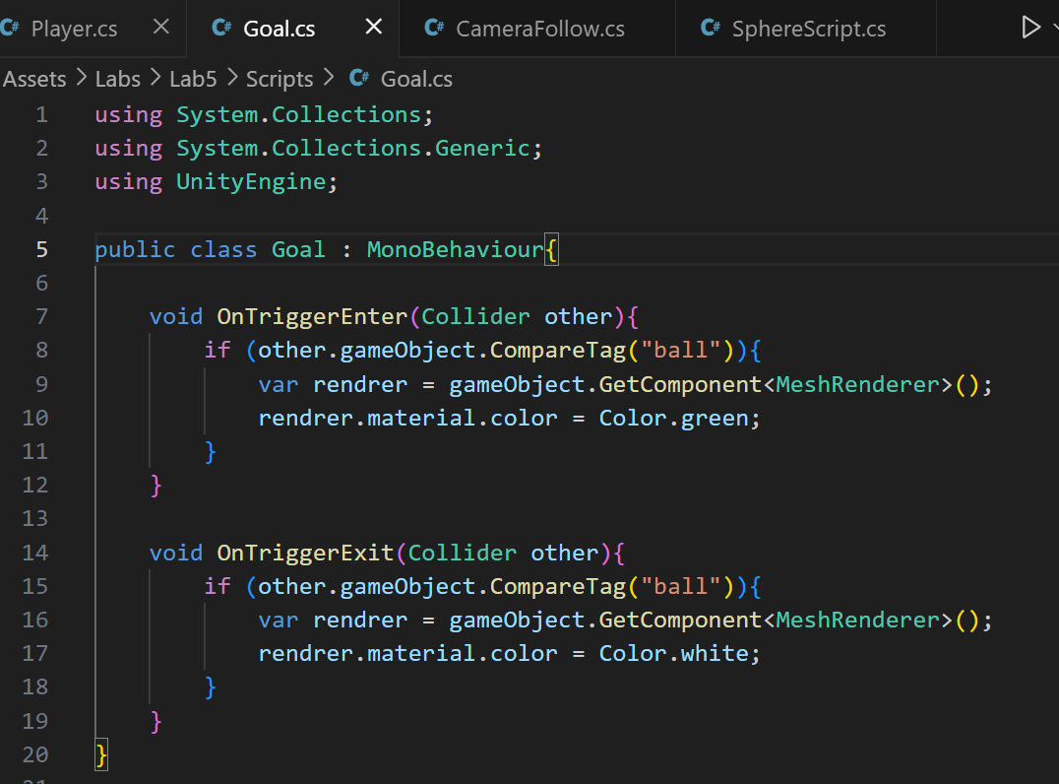

**Sphere class**

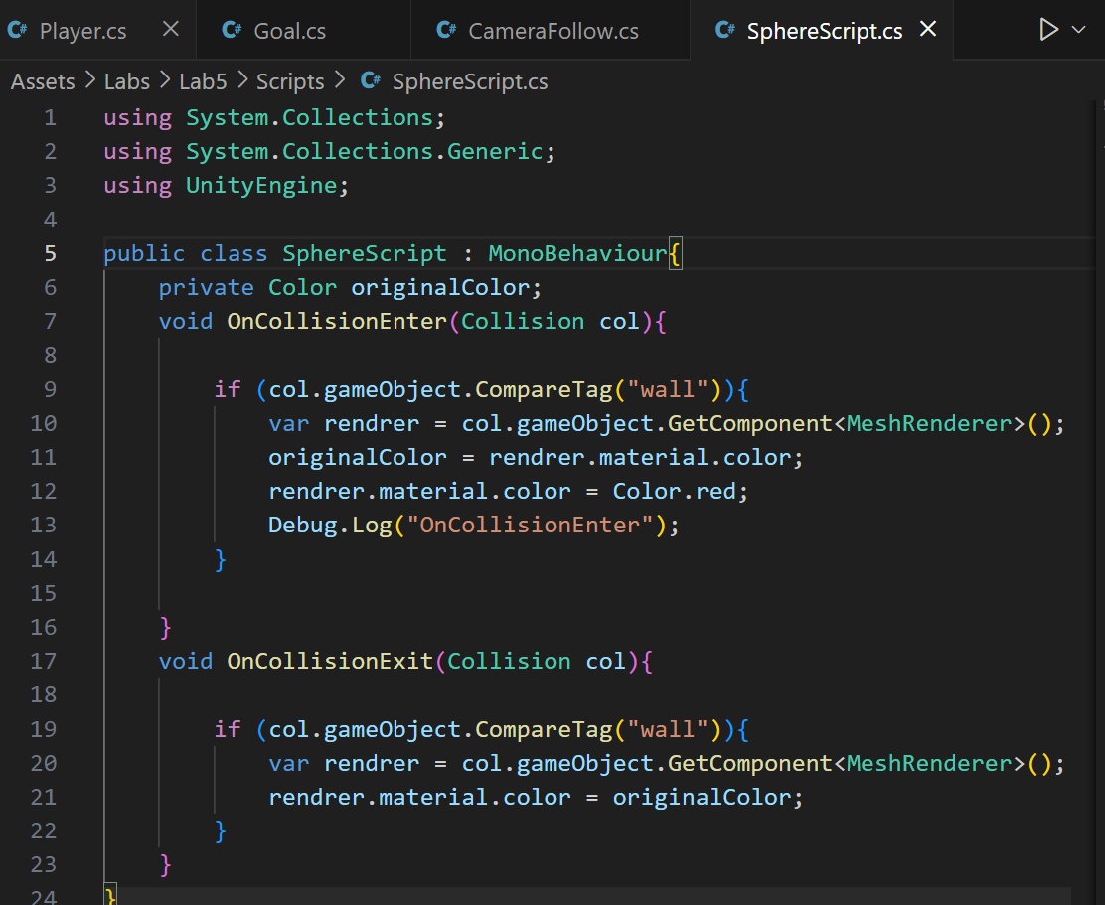

**CameraFollow class(additional)**

**Output:**

